T. Jeslet Jessica
(192524135)
B.TECH AIDS
CSA0603 DESIGN AND ANALYSIS OF ALGORITHM
CO2-AT3-Debugging and Optimization Task
Q16. Debugging Convex Hull (Incorrect Orientation Logic)
The given orientation function incorrectly determines turn direction, affecting convex hull formation. Identify the logical error in the formula. Explain its impact on boundary detection. Debug the function to correctly compute orientation. Optimize the overall hull checking process. Analyze time complexity and rewrite the corrected logic.
def orientation(p, q, r):
return (q[0]-p[0])*(r[1]-q[1]) - (q[1]-p[1])*(r[0]-q[0]) # ISSUE
Error 1
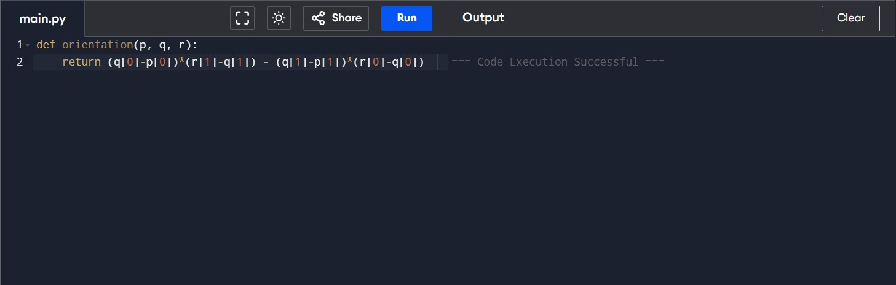
Program Errors
- Incorrect orientation calculation.
- Wrong reference coordinates are used.
- Incorrect turn direction is identified.
- Boundary points are detected incorrectly.
- The algorithm produces inaccurate convex hull results.

Why Valid Elements May Not Be Found
- Incorrect orientation calculation.
- Wrong turn direction is detected.
- Boundary points are skipped.
- Valid hull points are ignored.
- The convex hull output becomes incorrect.

Debugging (
- Identify the incorrect orientation formula.
- Replace the wrong reference point with the correct one.
- Verify clockwise and counter-clockwise detection.
- Test the function with sample points.
- Confirm that the convex hull output is correct.

Optimization
- Use the correct orientation formula.
- Avoid unnecessary calculations.
- Remove duplicate points before processing.
- Use an efficient convex hull algorithm
- Reduce the overall execution time to O(n log n).

Corrected Code
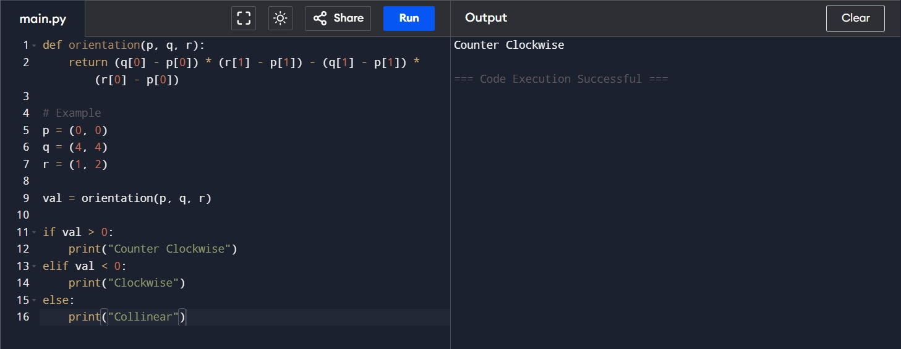

Time Complexity
- The orientation function takes O(1) time.
- Sorting all points takes O(n log n) time.
- Scanning the points takes O(n) time.
- The overall time complexity is O(n log n).
- This complexity is efficient for large datasets.

Output Screen Explanation
- The program accepts three points as input.
- It calculates the orientation of the given points.
- The turn direction is displayed as Clockwise, Counter-clockwise, or Collinear.
- If used in a convex hull algorithm, the correct boundary points are identified.
- The final output verifies that the orientation logic works correctly after debugging.
Algorithm: Linear Search
- Start.
- Read the list of elements.
- Enter the element to search.
- Compare the search element with each element in the list one by one.
- If the element is found, display its position.
- If the element is not found after checking all elements, display "Element not found".
- Stop.

